1x [RS232 converter](https://www.sparkfun.com/products/11189)

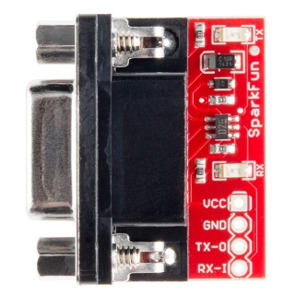1x [RS232 to TTL connector](https://www.sparkfun.com/products/449)

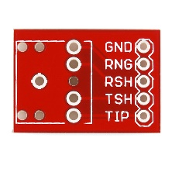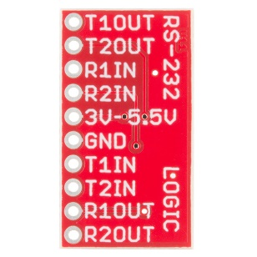2x [3.5mm jack](https://www.sparkfun.com/products/8032)

sx [3.5mm jack breakout](https://www.sparkfun.com/products/10588)

1x [RJ45 breakout](https://www.sparkfun.com/products/716)

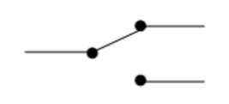1x [RJ45 8 pin connector](https://www.sparkfun.com/products/643)

4x [SPDT Slide switch](https://www.sparkfun.com/products/9609)

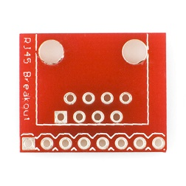2x [3mm Red LED](https://www.sparkfun.com/products/533)

